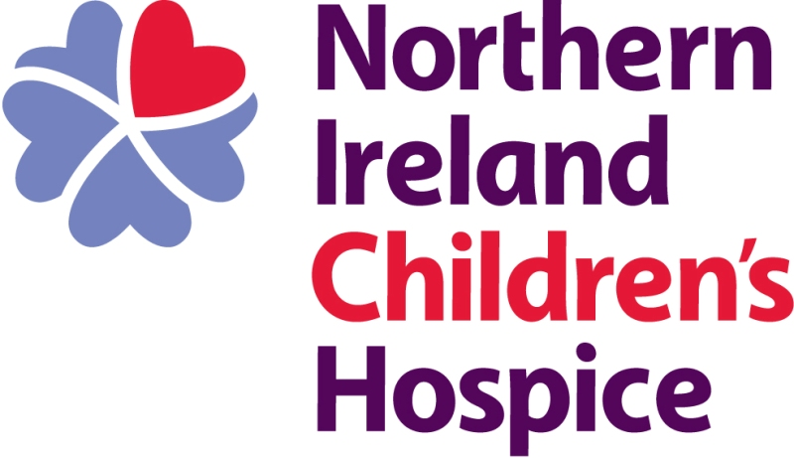

REFERRAL FORM

Guidance for referrers:
Thank you for considering referring a child to Northern Ireland Childrens Hospice.

Northern Ireland Childrens Hospice is a charity providing specialist palliative care to children and their families across Northern Ireland. Anyone can make a referral but we will need some basic medical information to move to the next stage so if you don’t have access to all of that it may be worthwhile asking one of the professionals involved in the care of the child to assist.

If you are making a referral for antenatal care you will need to use a different form it can be accessed at https://www.nihospice.org/referrals

Once your referral has been received we will arrange an assessment visit with the child and family and then the referral goes to a panel who will decide if we are the right service to help and what service we can provide. We will write to you once that decision is taken to let you know the outcome. We also write to the family.

Who we care for:
We care for babies, children and young people from 0 to 18 years of age and their families.

What everyone that uses our service will have in common is the expectation that the child will have a life limiting illness that will with all reasonable assessments limit their life to the childhood years. We base this on these categories:

Category 1 | Life threatening conditions for which curative treatment may be feasible but can fail, where access to palliative care services may be necessary when treatment fails or during acute crisis.
Category 2 | Conditions where premature death is inevitable, these may involve long periods of intensive disease – directed treatment aimed at prolonging life and allowing participation in normal activities. Children in this category may have relatively long periods of good health and while being significantly disabled may not need active palliative care.
Category 3 | Progressive conditions without curative treatment options, where treatment is exclusively palliative and may commonly extend over many years.
Category 4 | Irreversible but non progressive conditions causing severe disability leading to susceptibility to health complications and likelihood of premature death. Active palliative care may be required at any stage and include unpredictable and periodic episodes of care.

What we offer:
Northern Ireland Childrens Hospice offers different levels of support that can be tailored to the different stages of any child and family across their disease process. They are:
- Family Support
- Psychosocial Support
- Supported Short Breaks
- Symptom Management
- End of Life Care
- Care at Home.

The panel that decides if the children meet the criteria for service will tailor our service offer to best meet the assessed needs.

If you have any questions in the meantime please contact Horizon House on 028 9077 7635.
Details of person referring the child:
Name

Job Title/Relationship to Child:

Organisation

Address |  | Town
County |  | Postcode
Telephone | Mobile |  | Email

Consent:
Please confirm you have spoken to the people who hold parental responsibility for this child and that they give permission for this referral to proceed.

I have had a conversation with the people who hold parental responsibility for this child and confirm that they give permission for this referral to proceed. As part of that conversation I have informed the parties that NICH may access the Northern Ireland Electronic Care Record to get basic medical information relating to the referral. NICH will hold all this information in line with Data Protection legislation. | 
Signature: | Date:

Child’s details:
First name | Surname |  | DOB |  | Gender
Address |  |  | Town
County |  |  | Post code
Telephone Day |  | Telephone Night |  | Mobile
Ethnic Origin |  | Religion |  | H&C Number
Diagnosis:

Child’s awareness of diagnosis (if appropriate)

Outline and history of condition including any hospital admissions in the past year with reason for admissions and treatment level:

Breathing Difficulties:
SAO2 (normal range):
Is aspiration an issue? |  |  | Yes |  |  |  | No
Susceptible to/have a history of chest infections? |  |  | Yes |  |  |  | No
Scoliosis: |  |  | Severity:
Tracheostomy: |  |  | Yes |  |  |  | No
Interventions to maintain respirations: |  |  | Bi pap |  |  | C pap |  |  |  | Continuous O2
Nutrition and Hydration:
Enteral feeding (specify route):

Pain Control:
Type and source of pain:

Regular analgesia? |  |  | Yes |  |  |  | No
Type of analgesia:

Seizure Activity and Control:
Are seizures intractable? |  |  | Yes |  |  |  | No
Are they well controlled? |  |  | Yes |  |  |  | No
Is there a protocol for prolonged seizures? |  |  | Yes |  |  |  | No
Additional Information:

Expected Progression/Life Expectancy:

How would you assess this child’s phase of illness currently:

Stable |  | Unstable |  |  | Deteriorating |  |  |  | End of Life
- Symptoms are adequately controlled by an established plan of care  and  - Further interventions have been planned  and  - Family Situation is stable with no new issues |  | - New problem that was not anticipated  and/or  - A rapid increase in severity of a current issue  and/or  - Family circumstances change suddenly impacting on patient care |  |  | - Overall status is declining  and  - Experiences a gradual worsening of existing issues  and/or  - Experience a new but anticipated problem  and/or  - Family experience worsening distress that impacts on care |  |  |  | - Care is defined by focus of end phase of condition  - Withdrawal of treatment
Category:

What focus of care are you requesting:
- Family Support
- Psychosocial Support
- Supported Short Breaks
- Symptom Management
- End of Life Care
- Care at Home

Does this child have other supports in place:
Specify level of support:
Care package

Direct payments

Other respite services

Family Details:
Mother | First name | Surname |  | Address (if not same as child) | Health History
Father | First name | Surname |  | Address (if not same as child) | Health History
Siblings
Male/Female | First name | Surname | DOB | Address (if not same as child) | Health History
Male/Female | First name | Surname | DOB | Address (if not same as child) | Health History
Male/Female | First name | Surname | DOB | Address (if not same as child) | Health History
Male/Female | First name | Surname | DOB | Address (if not same as child) | Health History
Male/Female | First name | Surname | DOB | Address (if not same as child) | Health History

Relevant Social Information:

Name of person who holds parental responsibility
Details of shared care arrangement
(if applicable)
Is the child on the Child Protection Register: | Yes | No | Details:
Are there contact orders in place: | Yes | No | Details:
What level of Social Work input do the family have and what is the reason for this:

Have you any concerns regarding the child’s current care e.g. care package/parental confidence/ability/family relationships or stress:

Professional’s signature:

Date:

Please return completed referral form to: childrens@nihospice.org

At Hospice …

Our Vision
Is that infants, children and adults with life-limiting and life-threatening illnesses and their families, receive palliative care of the highest standards, there by maximising their quality of life.

Our Mission
Is to inspire and deliver excellent and compassionate specialist palliative care via effective service models underpinned by exemplary education, innovation and research.

Our values

We believe in:

- A culture of respect and acceptance without distinction or judgement, where everyone can belong.

- Acting with courage, compassion and integrity to add value to all that we do.

- Being pioneering, professional and accountable to deliver our very best.

Reviewed: August 2019

